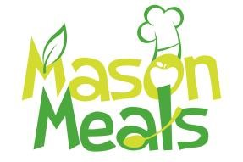
Field Trip
Sack Lunch Request Form

Regardless if sack lunches are needed, centers must notify Mason Meals Food Program when students go on a field trip. This is to ensure that Mason Meals is aware of fewer or no students will be receiving regular lunch and decrease the number of meals produced on the field trip date
- Sack lunches must be offered to all students attending field trip.
- Please contact Mason Meals at least 2 weeks prior to field trip and provide the following information.
(requests not made at least 1 week ahead of the trip will not be honored.)

Today’s Date _________________ Name of Center________________________ Trip Date: _______________
Center Address: ______________________________________ Departure Time_______________________
Please indicate if any student has allergy or special needs. ___________________________________________
___________________________________________________________________________________________
On the day of the field trip, the center is still responsible for making sure each student who receives a bag lunch get marked in for attendance and meals served on meal count roster using My Food Program.

X________________________________________ _____________________________________
Director Signature DATE

Lunch must be made available to ALL students on ALL school days, even when they are on a field trip. All students may participate if we have a completed enrollment and income eligibility form for that child.

Mason Meals Use Only
Received Date _____________________ ☐ APPROVED
☐ DECLINIED
X_________________________________________

