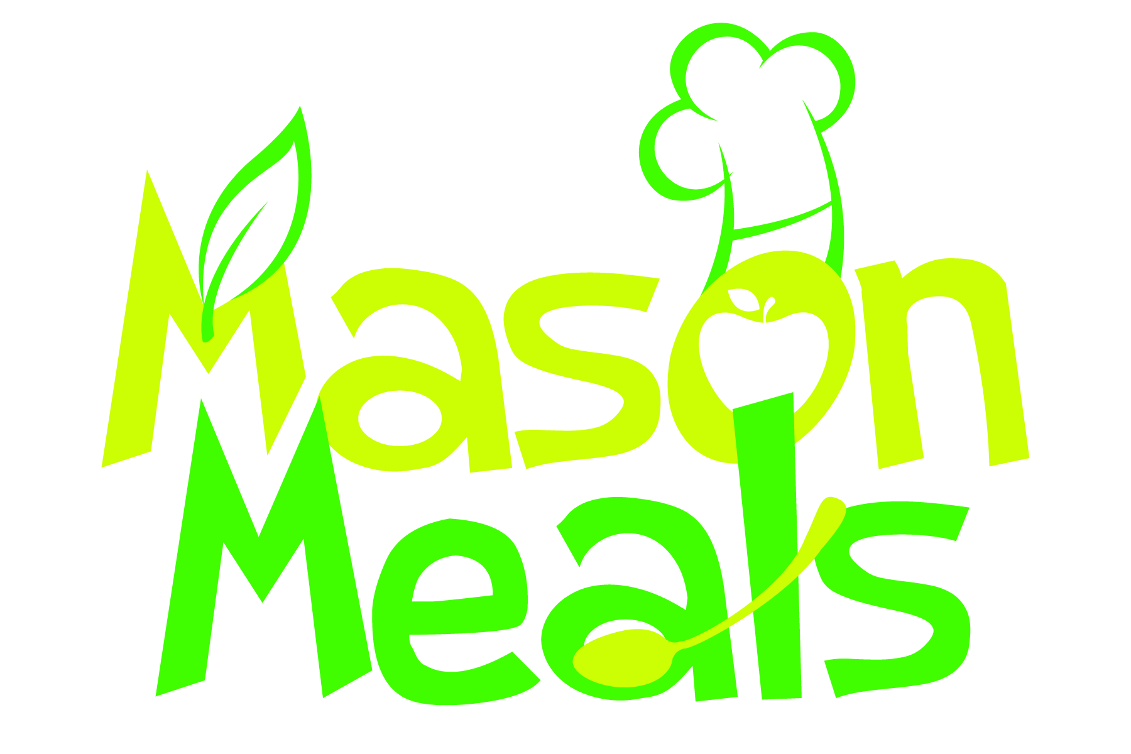
Mason Meals Serving Size Chart
Serving size was created using information from USDA Child Meal Pattern

All Fruit Juices Must Be 100% Juice & only served once per day.
Ages 2 and Up Is Served 1% Unflavored Milk
Ages 6-12 is Served 1% Flavored or Unflavored Milk
Ages Under 2yr Is Served Whole Milk ONLY!

Please feel to contact our office should you have any questions.
Serving Spoons are provided by Mason Meals
Please call Us ASAP if your center needs serving spoons

GREEN = 4oz Serving Spoon
YELLOW = 1 oz Serving Spoon
RED = 2oz Serving Spoon

Mason Meals Items | Ages 1-2 | Ages 3-5 | Ages 6-12
Animal Crackers | 1 Bag | 1 Bag | 1 Bag
Alfredo | 1 Serv. Spoon | 2 Serv. Spoons | 3 Serv. Spoons
All Fruit | ¼ Cup = 2 oz. | ¼ Cup = 2 oz. | ¼ Cup = 2 oz.
All Vegetables | ¼ Cup = 2 oz. | ¼ Cup = 2 oz. | ½ Cup = 4 oz.
Apple Slices Fresh | 1 Bag= 2 oz. | 1 Bag | 1 Bag
Apple Pancake | 1 Each | 1 Each | 1 Each
Angus Beef Slider | 1Each | 1Each | 1Each
Baked Ziti | 1 ½ Serv. Spoon | 2 Serv. Spoons | 2 ½ Serv. Spoons
Bagel Mini | ½ Slice | 1 EACH | 1 EACH
Banana Bread | 1 Each | 1 Each | 1 Each
Bean Salad | ¼ Cup – 2oz. | 3/8 Cup | ½ Cup = 4 oz.
Berries Mixed | 1oz – 1 Spoon | 2 oz 1 Spoon | 2 oz 1 Spoon
Beef A Roni | 4 Pcs. | 5 Pcs. | 6 Pcs. – 2 oz.
Blueberry Pancake | 1 Each | 1 Each | 1 Each
Cereal | 1 Bowl | 1 Bowl | 1 Bowl
Cereal Bar | ½ Piece | ¾ Piece | 1 Piece
Cheese Calzone | 1 Piece | 2 Pieces | 3 Pieces
Cheese Omelets | ½ Piece | 1 Whole | 1 Whole
Cheese Pizza | 1 Slice | 1 Slice | 1 Slice
Cheese Stix | ½ Stick | 1 Whole Stick | 1 Whole Stick
Cheese Tortellini | 2 Spoons =1oz | 1 Spoon =2oz | 1 Spoon = 2oz
Chicken Quesadilla | 1 Each | 1 Each | 1 Each
Chicken Breast Patty | ½ Piece | 1 Piece | 1 Piece
Chicken Nuggets | 3 Pieces | 4 Pieces | 5 Pieces
Chicken Salad | 1 Spoon (1oz) | 1 Spoon (2oz) | 1 Spoon (2 oz)
Chicken Taco | 2 Each | 3 Each | 3 Each
Chicken Sliders | ½ Slider | ¾ Slider | 1 Slider
Chicken Fries | 3 Stix | 4 Stix (2oz) | 4 Stix (2oz)
Chicken Pulled BBQ | 1 Spoon (1oz) | 1 Spoon (2oz) | 1 Spoon (2oz)
Corn Dog (Turkey) | 3 Each | 4 Each (1 1/2oz) | 6 Each (2oz)
Egg Frittata’s | 1 Each | 1 Each | 1 Each
Fish Cake | ½ Cake | 1 Cake | 1 Cake
Fish Sticks | 1 oz.= 2 Stixs | 3 Stix | 2 oz.= 4 Stixs
French Fries (Thin) | 5 Pieces | 7 Pieces | 10 Pieces
French Fry Smiley | 3 Pieces | 4 Pieces | 4 Pieces
French Toast Stix | 2 Stixs | 3 Stcks | 3 Sticks
Fruit Bar | 1 Bar | 1 Bar | 1 Bar
Fruit Cup | 1 Each (4oz) | 1Each (4oz) | 1 Each (4oz)
Graham Crackers | 1 Pack | 1 Pack | 1 Pack
Hash Brown | ½ Piece | 1 Piece | 1 Piece
Juice Breakfast | 2 oz. | 4 oz. | 4 oz.
Juice Snack | 4 oz. | 4 oz. | 6 oz.
Macaroni & Cheese | 1 Serv. Spoon | 1 ½ Serv. Spoon | 1 Serv. Spoon
Mashed Potatoes | 2oz.= 1 Serv. Sp. | 1 Serv. Spoon(4oz) | 1 Serv. Spoon (4oz)
Meatballs | 1oz= 2 Balls | 1 ½ oz.= 3 Balls | 2oz.= 4 Balls
Meatloaf | 1 Steak | 1 Steak | 1 Steak
Milk Breakfast | 4oz.= ½ Cup | 6oz.= ¾ Cup | 8oz. = 1 Cup
Milk Lunch | 4oz. = ½ Cup | 6oz. = ¾ Cup | 8oz. = 1 Cup
Milk Snack | 4oz. = ½ Cup | 6oz. = ¾ Cup | 8oz. = 1 Cup
Mozzarella Stick | 2 Sticks | 3 Sticks | 4 Sticks
Pancakes | 1 Piece | 1 ½ Piece | 2 Pieces
Pancake Wrap (BK) | 1 Each | 1 Each | 1 Each
Popcorn Chicken | 3 Pcs =1oz | 5 Pcs =2oz | 6 Pcs = 2oz
Ravioli | 2 Pieces= 1 oz. | 1 Serving Spoon | 1 Serving Spoon
Rice Cakes | 1 Bag | 1 Bag | 1 Bag
Rice Pilaf | ¼ Cup= 2 oz. | 1 Serving Spoon | 1 Serving Spoon
Sandwiches | ½ Sandwich | 1 Whole | 1 Whole
Sliced Bread | ½ Slice | ½ Slice | 1 Whole
Slice Turkey | 2 Slices | 2 Slices | 3 Slices
Sloppy Joe | 1 Spoon (1oz) | 1 Spoon (2oz) | 1 Spoon (2oz)
Tuna Salad | 1 Spoon ( 1oz) | 1 Spoon (2oz) | 1 Spoon (2 oz)
Turkey Franks | ½ Piece | 1 Piece | 1 Piece
Turkey Sausage Link | 1 Each | 2 Links | 2 Links
Turkey Goulash | 1 Serv. Spoon | 1 Serv. Spoons  4 oz | 2 Serv. Spoons  4oz
Waffles | 1 Piece | 1 ½ Pieces | 2 Pieces
Yogurt | 4 oz.= 1 | 4 oz.= 1 | 4 oz.= 1

